Machine learning Lab Observation
ITA0614

Experiment 4

Build an Artificial Neural Network by implementing the Backpropagation algorithm and test the same using appropriate data sets.

Name : Sakthi K S
Reg.No : 192412247

Problem 1: LED Brightness Level Classification
Aim
To build an artificial neural network using Backpropagation to classify LED brightness from input voltage and ambient-light conditions.
Algorithm
1. Initialize the weights and biases of the input, hidden and output layers with small values.
2. Provide the training inputs and their target outputs to the neural network.
3. Perform forward propagation to calculate the hidden-layer and output-layer values.
4. Calculate the error by comparing the predicted output with the target output.
5. Propagate the error backward and calculate the required weight corrections.
6. Update weights and biases using a suitable learning rate.
7. Repeat the forward and backward propagation for the required number of epochs until the error is reduced.
8. Test the trained neural network with a new sample and display the predicted class.
Program:
# Artificial Neural Network using Backpropagation
import numpy as np
def sigmoid(x):
return 1 / (1 + np.exp(-x))
def sigmoid_derivative(x):
return x * (1 - x)
# Encode the categorical training data numerically.
# Initialize weights and biases.
# Perform forward propagation.
# Calculate output error.
# Perform backpropagation and update weights.
# Repeat training for several epochs.
# Predict the class of a new sample.
Input
Training data set:
InputVoltage | AmbientLight | Brightness
Low | Dark | Low
Low | Normal | Low
Medium | Dark | Medium
Medium | Normal | Medium
High | Dark | High
High | Normal | High
Medium | Bright | Low
High | Bright | Medium
New sample: ('Medium', 'Bright')
Output
Training completed using the Backpropagation algorithm.
New sample: ('Medium', 'Bright')
Prediction: Brightness = Low
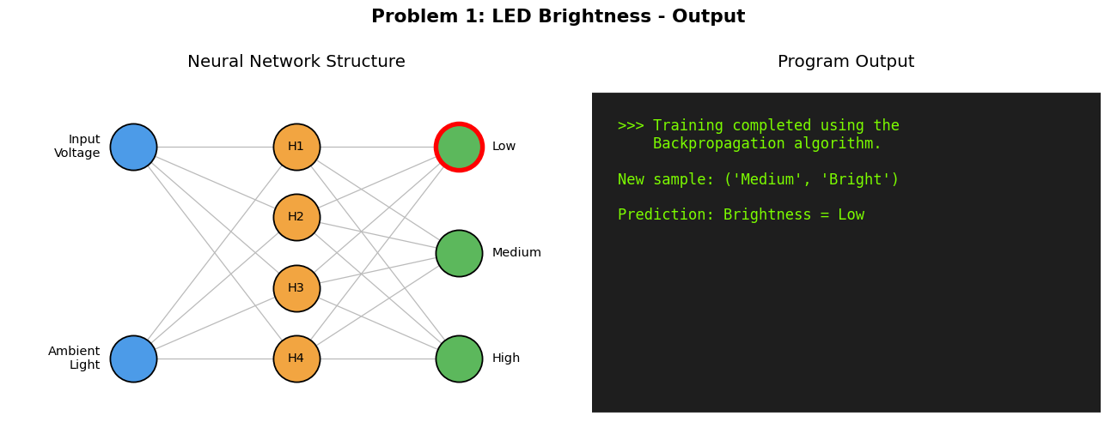
Result
The Artificial Neural Network was successfully trained using Backpropagation. The new sample ('Medium', 'Bright') was classified as Brightness = Low.
Problem 2: Motor Operating Condition Classification
Aim
To implement a Backpropagation neural network for identifying the operating condition of a motor from vibration and temperature measurements.
Algorithm
1. Initialize the weights and biases of the input, hidden and output layers with small values.
2. Provide the training inputs and their target outputs to the neural network.
3. Perform forward propagation to calculate the hidden-layer and output-layer values.
4. Calculate the error by comparing the predicted output with the target output.
5. Propagate the error backward and calculate the required weight corrections.
6. Update weights and biases using a suitable learning rate.
7. Repeat the forward and backward propagation for the required number of epochs until the error is reduced.
8. Test the trained neural network with a new sample and display the predicted class.
Program:
# Artificial Neural Network using Backpropagation
import numpy as np
def sigmoid(x):
return 1 / (1 + np.exp(-x))
def sigmoid_derivative(x):
return x * (1 - x)
# Encode the categorical training data numerically.
# Initialize weights and biases.
# Perform forward propagation.
# Calculate output error.
# Perform backpropagation and update weights.
# Repeat training for several epochs.
# Predict the class of a new sample.
Input
Training data set:
Vibration | Temperature | Condition
Low | Normal | Healthy
Low | High | Warning
Medium | Normal | Healthy
Medium | High | Warning
High | Normal | Warning
High | High | Fault
High | VeryHigh | Fault
Medium | VeryHigh | Fault
New sample: ('High', 'High')
Output
Training completed using the Backpropagation algorithm.
New sample: ('High', 'High')
Prediction: Condition = Fault
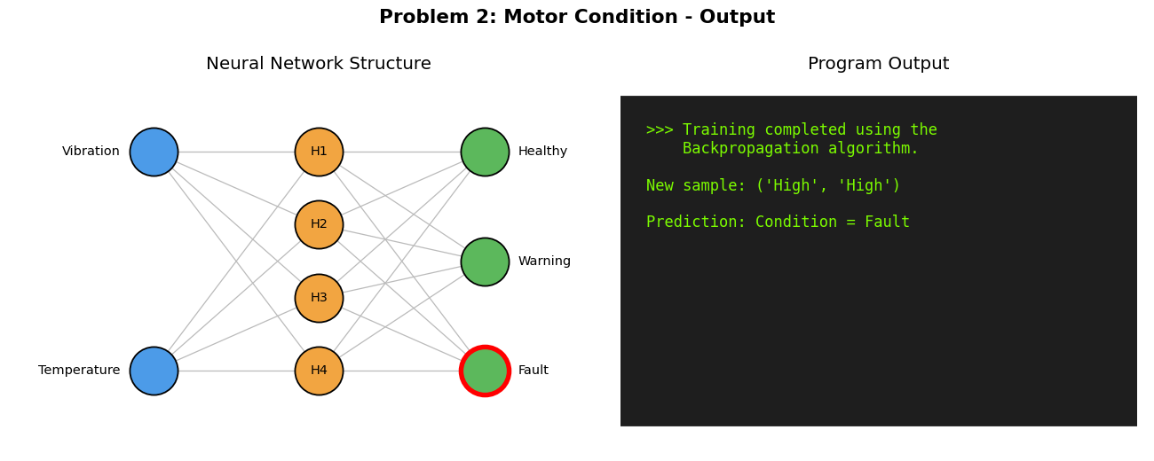
Result
The Artificial Neural Network was successfully trained using Backpropagation. The new sample ('High', 'High') was classified as Condition = Fault.
Problem 3: Water Quality Category Classification
Aim
To construct an Artificial Neural Network using Backpropagation to classify water quality based on pH level, turbidity and dissolved oxygen.
Algorithm
1. Initialize the weights and biases of the input, hidden and output layers with small values.
2. Provide the training inputs and their target outputs to the neural network.
3. Perform forward propagation to calculate the hidden-layer and output-layer values.
4. Calculate the error by comparing the predicted output with the target output.
5. Propagate the error backward and calculate the required weight corrections.
6. Update weights and biases using a suitable learning rate.
7. Repeat the forward and backward propagation for the required number of epochs until the error is reduced.
8. Test the trained neural network with a new sample and display the predicted class.
Program:
# Artificial Neural Network using Backpropagation
import numpy as np
def sigmoid(x):
return 1 / (1 + np.exp(-x))
def sigmoid_derivative(x):
return x * (1 - x)
# Encode the categorical training data numerically.
# Initialize weights and biases.
# Perform forward propagation.
# Calculate output error.
# Perform backpropagation and update weights.
# Repeat training for several epochs.
# Predict the class of a new sample.
Input
Training data set:
pH | Turbidity | DissolvedOxygen | Quality
Neutral | Low | High | Good
Neutral | Low | Medium | Good
Acidic | High | Low | Poor
Alkaline | High | Low | Poor
Neutral | Medium | High | Good
Acidic | Medium | Low | Poor
Alkaline | Medium | High | Average
Neutral | High | Medium | Average
New sample: ('Neutral', 'High', 'Medium')
Output
Training completed using the Backpropagation algorithm.
New sample: ('Neutral', 'High', 'Medium')
Prediction: Quality = Average
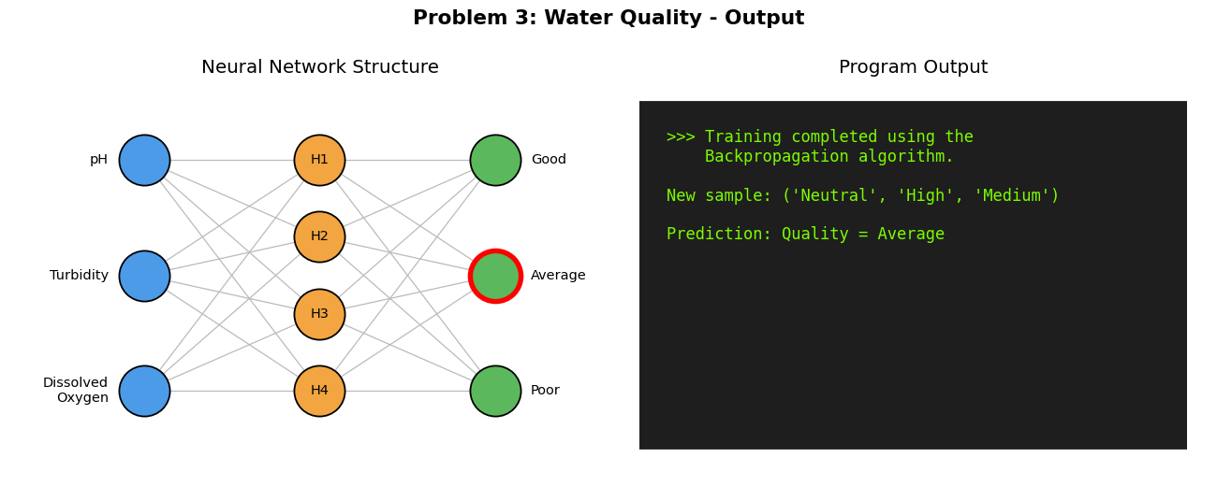
Result
The Artificial Neural Network was successfully trained using Backpropagation. The new sample ('Neutral', 'High', 'Medium') was classified as Quality = Average.
Problem 4: Solar Panel Performance Classification
Aim
To develop a Backpropagation neural network to classify solar panel performance using sunlight intensity, panel temperature and dust level.
Algorithm
1. Initialize the weights and biases of the input, hidden and output layers with small values.
2. Provide the training inputs and their target outputs to the neural network.
3. Perform forward propagation to calculate the hidden-layer and output-layer values.
4. Calculate the error by comparing the predicted output with the target output.
5. Propagate the error backward and calculate the required weight corrections.
6. Update weights and biases using a suitable learning rate.
7. Repeat the forward and backward propagation for the required number of epochs until the error is reduced.
8. Test the trained neural network with a new sample and display the predicted class.
Program:
# Artificial Neural Network using Backpropagation
import numpy as np
def sigmoid(x):
return 1 / (1 + np.exp(-x))
def sigmoid_derivative(x):
return x * (1 - x)
# Encode the categorical training data numerically.
# Initialize weights and biases.
# Perform forward propagation.
# Calculate output error.
# Perform backpropagation and update weights.
# Repeat training for several epochs.
# Predict the class of a new sample.
Input
Training data set:
Sunlight | PanelTemp | DustLevel | Performance
Low | Low | Low | Low
Medium | Normal | Low | Medium
High | Normal | Low | High
High | High | Low | Medium
High | Normal | High | Medium
Medium | High | High | Low
Low | Normal | High | Low
Medium | Normal | Medium | Medium
New sample: ('High', 'Normal', 'High')
Output
Training completed using the Backpropagation algorithm.
New sample: ('High', 'Normal', 'High')
Prediction: Performance = Medium
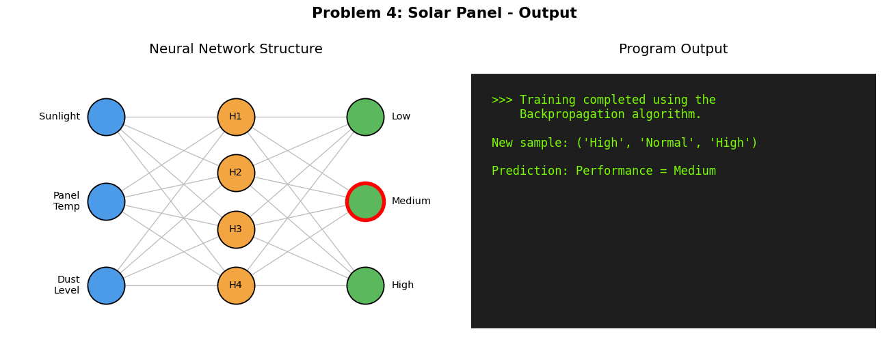
Result
The Artificial Neural Network was successfully trained using Backpropagation. The new sample ('High', 'Normal', 'High') was classified as Performance = Medium.
Problem 5: Network Traffic Condition Classification
Aim
To implement an Artificial Neural Network with Backpropagation for classifying network traffic condition from bandwidth usage, packet rate and delay.
Algorithm
1. Initialize the weights and biases of the input, hidden and output layers with small values.
2. Provide the training inputs and their target outputs to the neural network.
3. Perform forward propagation to calculate the hidden-layer and output-layer values.
4. Calculate the error by comparing the predicted output with the target output.
5. Propagate the error backward and calculate the required weight corrections.
6. Update weights and biases using a suitable learning rate.
7. Repeat the forward and backward propagation for the required number of epochs until the error is reduced.
8. Test the trained neural network with a new sample and display the predicted class.
Program:
# Artificial Neural Network using Backpropagation
import numpy as np
def sigmoid(x):
return 1 / (1 + np.exp(-x))
def sigmoid_derivative(x):
return x * (1 - x)
# Encode the categorical training data numerically.
# Initialize weights and biases.
# Perform forward propagation.
# Calculate output error.
# Perform backpropagation and update weights.
# Repeat training for several epochs.
# Predict the class of a new sample.
Input
Training data set:
BandwidthUsage | PacketRate | Delay | Traffic
Low | Low | Low | Normal
Medium | Medium | Low | Normal
High | High | Low | Congested
High | High | High | Congested
Medium | High | Medium | Busy
High | Medium | High | Busy
Low | High | Low | Busy
Medium | Low | Low | Normal
New sample: ('High', 'Medium', 'High')
Output
Training completed using the Backpropagation algorithm.
New sample: ('High', 'Medium', 'High')
Prediction: Traffic = Busy
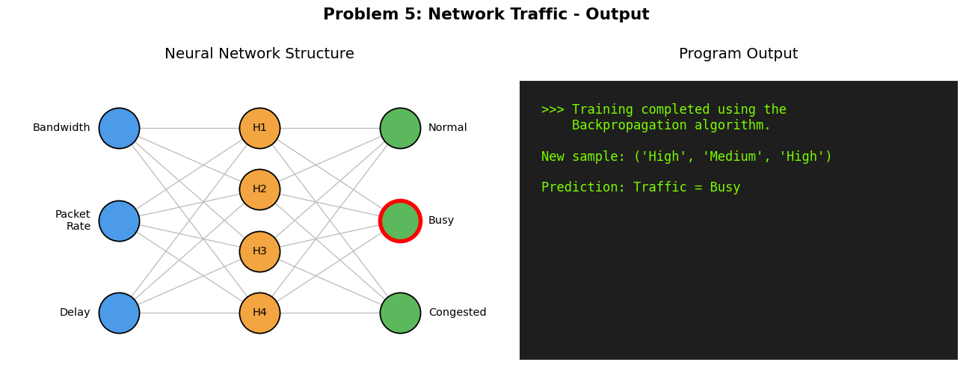
Result
The Artificial Neural Network was successfully trained using Backpropagation. The new sample ('High', 'Medium', 'High') was classified as Traffic = Busy.

